https://www.youtube.com/watch?v=JSvVsOm4oX0

Comparable and comparator are two interfaces provided by Java for comparing objects and sorting them.

We use Collections.sort(). It has two variants:

* Collections.sort(List<T>)
* Collections.sort(List<T>, Comparator<?superT>)

**Collections.sort(List<T>):**

Now the first one takes the list argument which contains the data to be sorted. T is the type of data tat the list hold and will be sorted. Now in this one, the type T must implement Comparable<Object> interface and implement compareTo(Object o) method. Now our implementation of the class to be compared i.e. T will go inside here.

So this one associated with Comparable interface.

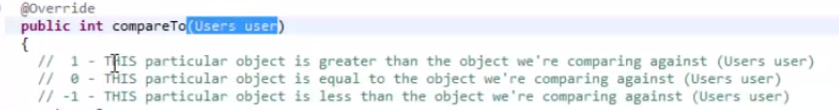

Comparable is more used for Objects made by programmer and when he wants to do comparing and sorting of those objects putting them inside a collection in the way defined by him.

**Collections.sort(List<T>,Comparator<?superT>):**

For cases when we want to alter the implementation of compareTo of Java Defined objects like String we use comparator.

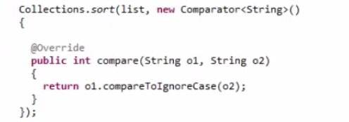

So here what we do is we, in the second parameter create an anonymous comparator class and override the compare method passing in the two objects to compare. And now define how will the two objects in consideration will be compared at any given point of time.

|  |  |
| --- | --- |
| **Comparable** | **Comparator** |
| 1) Comparable provides **single sorting sequence**. In other words, we can sort the collection on the basis of single element such as id or name or price etc. | Comparator provides **multiple sorting sequence**. In other words, we can sort the collection on the basis of multiple elements such as id, name and price etc. |
| 2) Comparable **affects the original class** i.e. actual class is modified. | Comparator **doesn't affect the original class** i.e. actual class is not modified. |
| 3) Comparable provides **compareTo() method** to sort elements. | Comparator provides **compare() method** to sort elements. |
| 4) Comparable is found in **java.lang** package. | Comparator is found in **java.util** package. |
| 5) We can sort the list elements of Comparable type by **Collections.sort(List)** method. | We can sort the list elements of Comparator type by **Collections.sort(List,Comparator)** method. |